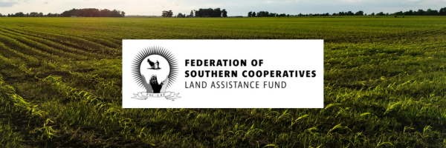

The Federation of Southern Cooperatives/Land Assistance Fund has received reports from community members in Alabama’s Black Beltregion about a possible scam targeting farmers and rural residents.

Important Notice to Our Community

The Federation has received reports from community partners that individuals may be targeting farmers and rural residents with fraudulent offers to complete a supposed “Black Farmers application” connected to a lawsuit in exchange for a fee.
At this time, USDA offices have indicated that no such application currently exists.
The Federation is not connected to any individual or organization charging fees to complete a “Black Farmers application".
Our staff regularly provide education, outreach, and technical assistance to farmers and landowners. The Federation is not connected to any individual offering paid assistance for a “Black Farmers application,” and our staff would not contact community members requesting payment to complete such applications.

If someone claims to represent the Federation and asks for payment, please contact our offices listed below to verify before making any payment.
If legitimate claims processes, lawsuits, or government programs become available, the Federation will share accurate information through our official website, email communications, and trusted community partners.

How to Protect Yourself
Farmers and landowners should be cautious if someone:
• Claims to represent the Federation without verification
• Requests payment to complete forms related to lawsuits or farmer assistance programs
• Promises access to settlement funds or government benefits in exchange for a fee
Important Reminders:
• No Application Fees: The USDA does not charge to participate in these programs.
• No Active USDA DFAP: The application deadline for the Discrimination Financial Assistance Program was January 13, 2024.
• Verified Resources: Information should only be taken from official USDA sources or established organizations such as the Federation.

What To Do If You Were Contacted
If you believe you have been contacted by someone offering this service, or if you may have paid money for assistance:
1. Report the situation to your local law enforcement office
2. Contact the Federation of Southern Cooperatives / Land Assistance Fund if you have questions or need help connecting to accurate information and legitimate resources. You can find our field office's numbers below.
Protecting the integrity of our communities and ensuring farmers have access to trustworthy information remains central to our mission.
Federation of Southern Cooperatives / Land Assistance Fund
Admin Office:
📞 404-765-0991
📧 info@federation.coop

RURAL TRAINING & RESEARCH CENTER
ALABAMA FIELD OFFICE
Call (205) 652-9670
Fax (205) 652-9678
​​
FLORIDA FIELD OFFICE
Call (386) 243-8179
​
​GEORGIA FIELD OFFICE
Call (229) 432-5799
Fax (229) 439-0894
​
MISSISSIPPI FIELD OFFICE
Call (601) 944-0592​
​​​
​​​LOUISIANA FIELD OFFICE
Call (318) 704-2423

​SOUTH CAROLINA
​Call 843-321-4171
​
​TEXAS FIELD OFFICE
Call (713) 634-7385



The Federation of Southern Cooperatives/Land Assistance Fund is a 58-year-old cooperative association of primarily Black farmers, landowners, and cooperatives founded directly out of the civil rights movement by twenty-two cooperatives.
Our mission is to be a catalyst for the development of self-supporting communities through cooperative economic development, land retention, and advocacy.
﻿We envision sustainable rural communities supported by a network of farmers, landowners, and cooperatives based on local control and ownership.

